Media Buyer Training: Campaign & Funnel Structures

Purpose
This SOP covers the fundamental structures you need to understand as a media buyer: how we set up campaigns, the metrics that matter, and the different funnel types we use for clients.

Your job isn't to build funnels or optimize landing pages. Your job is to launch campaigns, monitor the right metrics, and know when to flag issues to the fulfillment manager.

Part 1: Campaign Setup & KPIs

The Chadvertising Philosophy
Before we get into the technical setup, you need to understand the philosophy behind how we run campaigns. We call it "Chadvertising" because it's the opposite of what most geek media buyers do.

To succeed, you need to think of your metrics in three layers:
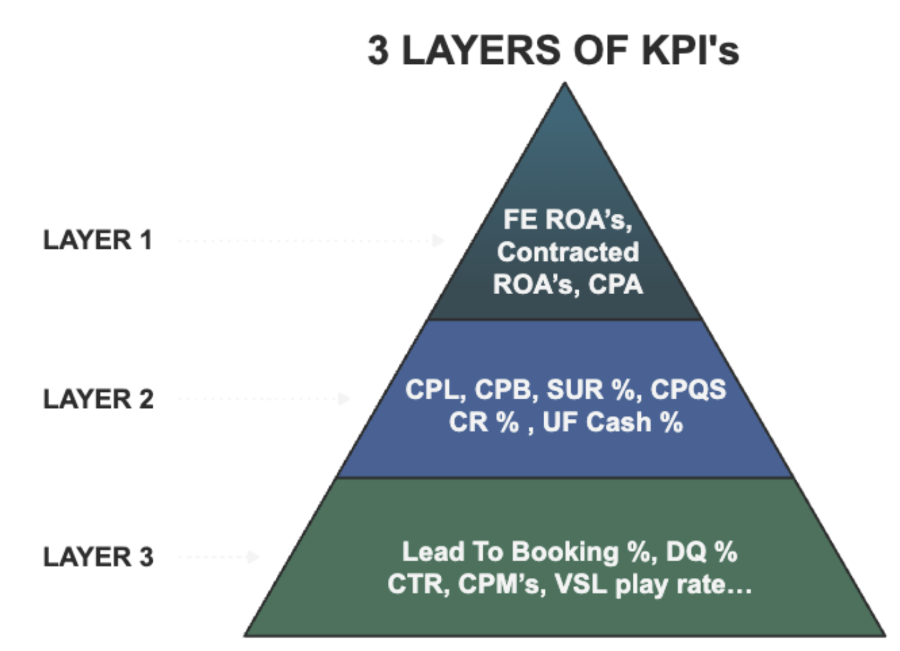

3 LAYERS OF KPI's
- Layer 1: These are the only metrics that actually pay the bills.
  - This is your FE ROAS (Upfront Cash ROA’s), your Contracted ROAS, and your CPA (Cost Per Acquisition).
- Layer 2: These are your core conversion metrics.
  - This is your CPL, CPB, Show Up Rate, CPQS, CR %, and UF cash %
- Layer 3: These are your micro metrics that tell you exactly where the constraint is in your acquisition process
  - Lead to booking %, DQ%, CTR, CPM’s…

GOLDEN RULE: If Layer 1 is profitable, I don't give a shit if a Layer 2 or 3 metric is way out of whack.

Most media buyers obsess over layer 2 and layer 3 metrics. They're constantly tweaking targeting, adjusting bids, turning ads off the second CTR dips by 0.2%, and generally just fucking with campaigns that are working.

Chadvertisers focus on one thing: metrics closest to the money.

If your CPL is on target and your client is closing deals, the campaign is working. I don't care if your CTR dropped from 3.2% to 2.9%. I don't care if your frequency is at 4.2 instead of 3.8. If the cost per lead is good and the leads are qualified, leave it the fuck alone.

The only time I look at layer 3 metrics (CTR, frequency, engagement) is when CPL goes off target. Then I'll dig in to diagnose what's wrong. But if CPL is good? I'm not touching anything.

This is the #1 mistake I see new media buyers make: they turn off winning ads because some secondary metric dipped. Don't be that person.

The 8-12 Creative Launch Strategy
When we launch a new client, here's exactly what we do:

We throw 8-12 creatives into ONE ad set, turn on CBO (Campaign Budget Optimization) with a $50-$100/day budget, and let it rip.

We usually always run manual placements specifically for just reels and stories, and turn off all Meta's AI Enhancement recommendations.

That's it. No complicated testing structure. No separate ad sets for each creative. Just one ad set, 8-12 ads, and let Facebook's algorithm figure out which ones work.

We do this because we know Facebook is a multi BILLION dollar platform and is 1000x smarter than us. If you give it 8-12 creatives to choose from, it will naturally allocate budget to the 3-4 that perform best. You don't need to manually test each one. The algorithm does it for you.

Within 48 hours, you'll see which ads are getting spend and which ones are being ignored. The ones getting spend are the ones Facebook thinks will perform. And 90% of the time, Facebook is right (Let me show you some examples of client campaigns and the structure…)

What If It Doesn't Work?
If after 48 hours none of the ads are performing (CPL is way above target, no leads coming in), here's what you do:
- Duplicate the entire campaign
- Turn off the ads that got spend but didn't perform
- Let the remaining ads run for another 48 hours

Usually, one of the ads that didn't get much spend in the first campaign will pop in the second one. Facebook just needed to test different combinations.

After repeating this process a few times and testing a few waves of creatives, we know it's usually an offer issue if nothing is working.

Campaign Structure & Targeting
- Campaign Level
  - Objective: Leads
  - Budget: CBO (Campaign Budget Optimization) at (Clients Budget) to start
  - Special Ad Category: Housing
- Ad Set Level
  - Targeting: We can’t target anything because of the special ad category settings
  - State Targeting: Start off by targeting the states they’re licensed in. If quality is an issue, then we pivot to counties with higher average property values
  - Language: English Only
- Ad Level
  - 8-12 creatives (mix of images and videos from the Reverse AD’s folder B2C
  - Ad copy:
  - Lead form or landing page (we'll cover this in a future video)
    - We’re running a mix of 3-5 headlines & ad copies too…

The 4 Main Metrics That Matter
Here are the only 4 metrics we check on a daily basis:

- CPL (Cost Per Lead) - This is the #1 metric. If CPL is on target, everything else is secondary.

- CPB (Cost per booking) - What percentage of leads are booking appointments? This tells you if the leads are qualified.

- Show Rate - What percentage of booked appointments actually show up? This tells you if your nurture is working.

- CPCONVO (Cost Per Conversation) - What does it cost to get our client a conversation with a lead? This is the ultimate metric.

That's it. We don't check CTR, frequency, or engagement unless CPL goes off target. Then we'll dig into those metrics to diagnose the issue.

Benchmarks
Here are the benchmarks:
- CPL: $10-$20
- CPQL: $25-$35 (Lead to qualifying shouldn’t be less than 50%)
- Schedule %: ~ 28%
- Cost Per Booking: ~$60-$80
- Show Rate: 60-70% (anything below 50% means your nurture sucks)
- CPA: This depends on your client's close rate and average sale price

Secondary Metrics (Only Check If CPL Is Off)
- CTR (Click-Through Rate): If CPL is high, check if CTR is low. Sub 2% CTR means your creative/copy isn't compelling.
- Frequency: If CPL is rising, check if frequency is above 3-4. High frequency means ad fatigue.
- Cost Per Booking: If Schedule % is low, check Cost Per Booking. High cost per booking means leads aren't qualified.

We track all of this data in our centralized client fulfilment sheet, let me show you how…

When to Kill an Ad (The 48-Hour Rule)

When it comes to killing ads and determining they don't work, my rules are as follows:
- Give every ad 48 hours to prove itself.
  - If an ad has 2 consecutive days where CPL is significantly above target (like 3x or more), kill it.
    - For ex: if your target CPL is $15, and Day 1 the ad runs at $40 CPL and Day 2 it runs at $110 CPL, turn it off. It's fatigued or the audience is tapped out
- If an ad spends 3x your target CPL and gets zero leads, kill it.
  - For ex: if your target CPL is $50, and an ad spends $150 with no leads, turn it off. It's not going to magically start working.

Sometimes an ad will have a slightly high CPL but a LOW Cost Per Booking because the Schedule % is really high.

For ex: if your target CPL is $50 but the ad is running at $60 CPL, BUT the Schedule % is 30% (way above your 12% benchmark), keep it running. The leads are more qualified, which means lower Cost Per Booking and higher close rate.

So keep in mind you don’t just wanna look at CPL in isolation. Look at the full funnel. If Cost Per Booking is good, the ad is working even if CPL is slightly high.

The key takeaway here is REPEAT SUCCESSFUL ACTIONS → if a specific creative is working for a handful of clients, replicate it across other underperforming clients and milk it for everything it’s worth.

Part 2: Sales Funnel Structure (Lead Forms vs. Landing Pages)
Our Default: We Start with Landing Pages

Here's the most important thing you need to understand: We ALWAYS start with landing pages (funnels), not lead forms.

Why? Because we've proven after a lot of data that it makes more sense for us to start with a funnel because we get better results from that.

We usually transition to a lead form if the client's CPL is too high AND the cost per booking is too high as well.

The key is this: The CPL may be too high, but if the cost per booking is within KPI, we're not going to touch it.

Example: Let's say the CPL is $20-$30 which is way out of KPI, but the cost per booking is within KPI ($100 or sub-$100), then we're not going to change anything. The funnel is working.

What is a Lead Form?
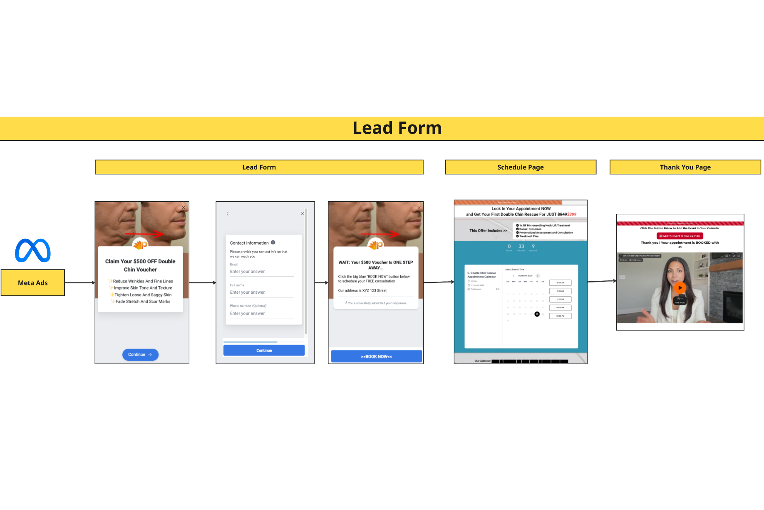
A lead form is a form that lives natively inside Facebook or Instagram. When someone clicks your ad, they never leave the platform. Instead, a form pops up right there in the app with their information already pre-filled (name, email, phone number) pulled from their Facebook profile.
- Pros: Higher lead flow, usually a lower Cost Per Lead (CPL), faster to set up, less friction (they never leave the platform)
- Cons: Lower intent, lower quality leads, lower lead-to-booking % (can't auto-redirect to calendar), less control over messaging

→ Miro Board Link

What is a Landing Page?
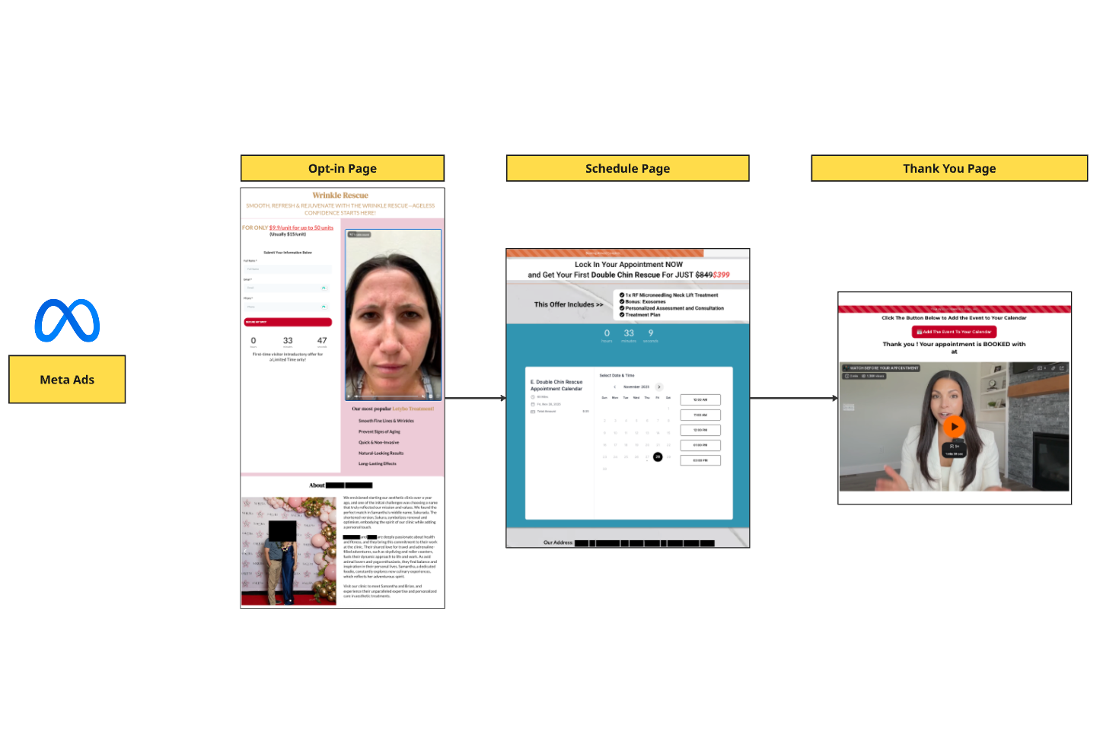
A landing page is an external page that we build (either on the client's website or in a tool like GoHighLevel). When someone clicks on the ad, they leave Facebook/Instagram and land on this page.

- Pros: Higher intent leads, more control over messaging (you can add a VSL, testimonials, case studies, etc.), auto-redirect to schedule page (higher lead-to-booking %), ability to pre-frame and educate before they book
- Cons: More friction (they have to leave the platform), usually a higher CPL, takes longer to set up

High Intent vs. Low Intent
We have two different types of landing pages:

1. High Intent Landing Page

This is a normal funnel with a bunch of education on it where we can really control the narrative.

Example: https://clinicpromos.com/home645313

2. Low Intent Landing Page (Squeeze Page)

This is what we call a squeeze page. When they try to scroll, they literally can't move up and down. They just have a headline and opt-in form. That's it.

This reduces friction. We'd rather do this first before going to a lead form.

Example: https://app.pinpointscaling.co.uk/v2/preview/zWj30uLqu0xz4pvw3ds1

When to Transition to a Lead Form // Low Intent LP
If one of your clients experiences the following, consult with the fulfillment manager to see if it makes sense to move to a lead form:

- CPL is too high (2x+ above target) AND Cost Per Booking is too high (above $100)
- You've already tested a Low Intent landing page and it's still not working
- Lead quality is good but volume is too low

Remember: We only transition to a lead form if BOTH CPL and Cost Per Booking are out of KPI. If Cost Per Booking is sub-$100, leave it alone even if CPL is high.

The Transition Process
If you and the fulfillment manager decide to move to a lead form, here's the process:

- Start with a Low Intent landing page first (squeeze page with just headline + opt-in)
- If that doesn't work, then move to a lead form
- Monitor CPL and Cost Per Booking closely to see if the transition improves performance

Your job is to flag the issue and consult with the fulfillment manager. They'll make the final call on whether to transition.

Key Takeaways
1. We ALWAYS start with landing pages (funnels), not lead forms.

2. Only transition to a lead form if BOTH CPL and Cost Per Booking are too high. If Cost Per Booking is sub-$80, leave it alone.

3. Try a Low Intent landing page (squeeze page) before moving to a lead form.

4. Campaign structure is simple: 8-12 creatives, one ad set, CBO at $50-$100/day, broad targeting.

5. Focus on Layer 1 metrics (CPL, CPB, Show Rate, CPA). Don't obsess over Layer 2 & 3 unless CPL is off.

6. Give every ad 48 hours to prove itself. Don't kill winners because a secondary metric dipped.

7. When you find a winner, milk it for everything it's worth. Scale it, iterate on it, replicate it.

8. If your client experiences performance issues, consult with the fulfillment manager before making changes.

